**Internship Title: Smart Agriculture System based on IOT - SB42054**

**Project ID:SPS_PRO_101**

**Project Title:Smart Agriculture system based on IoT**

**Project Mentor: Durgaprasad Sir from SmartBridge**

**Objective:**

* To make a smart APP
* App will give the data from IOT sensor
* App will give the data from open weather api
* These information's will help to make smart agriculture concept possible.

### Setup The Development Environment:

1. Create GitHub Account: I have created my GitHub Account. Here, I have attached that snapshot.

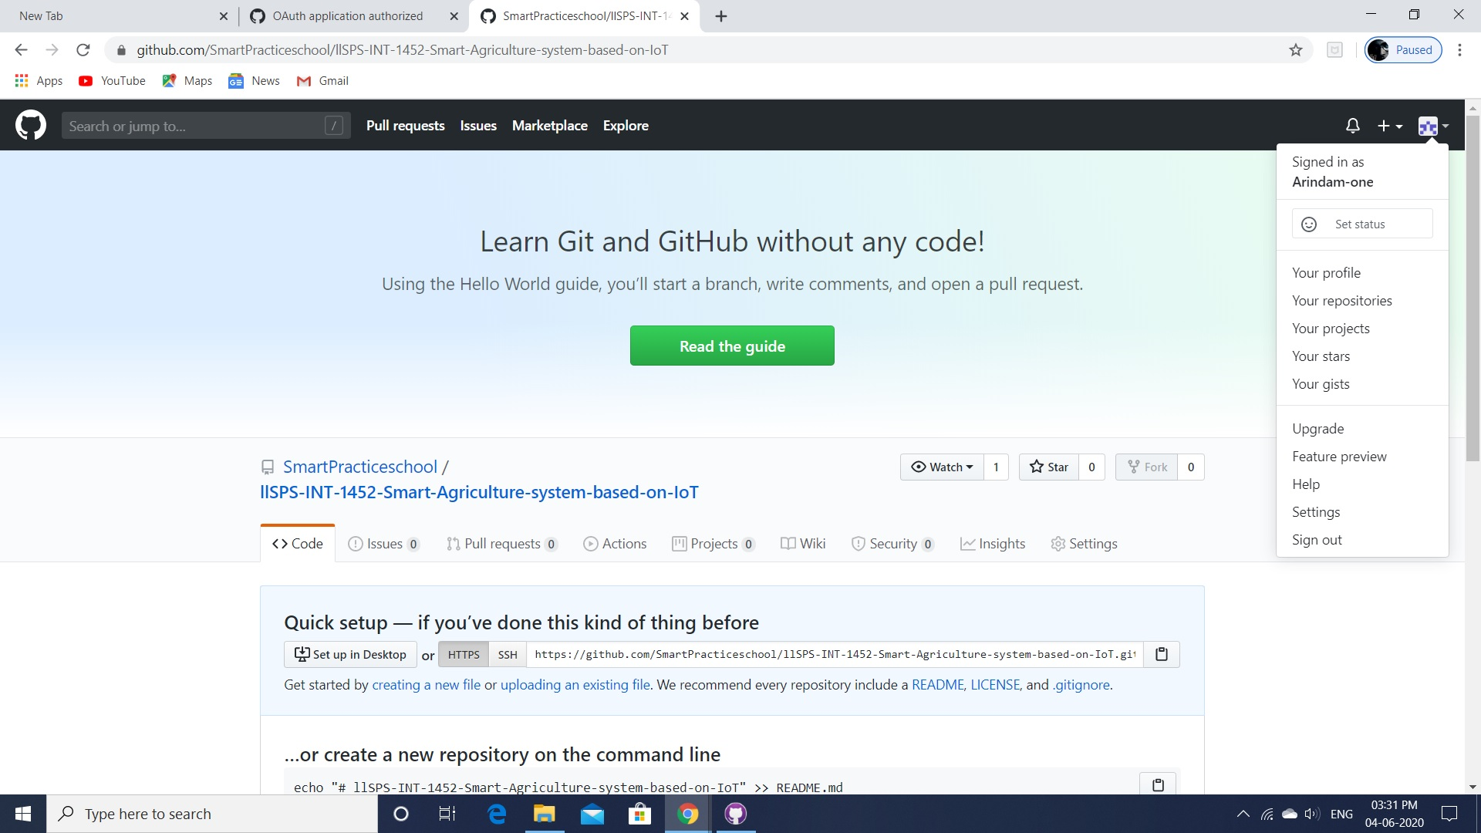

2. Install Slack and Create Account: I have created that account and I have already asked my problems to do this internship.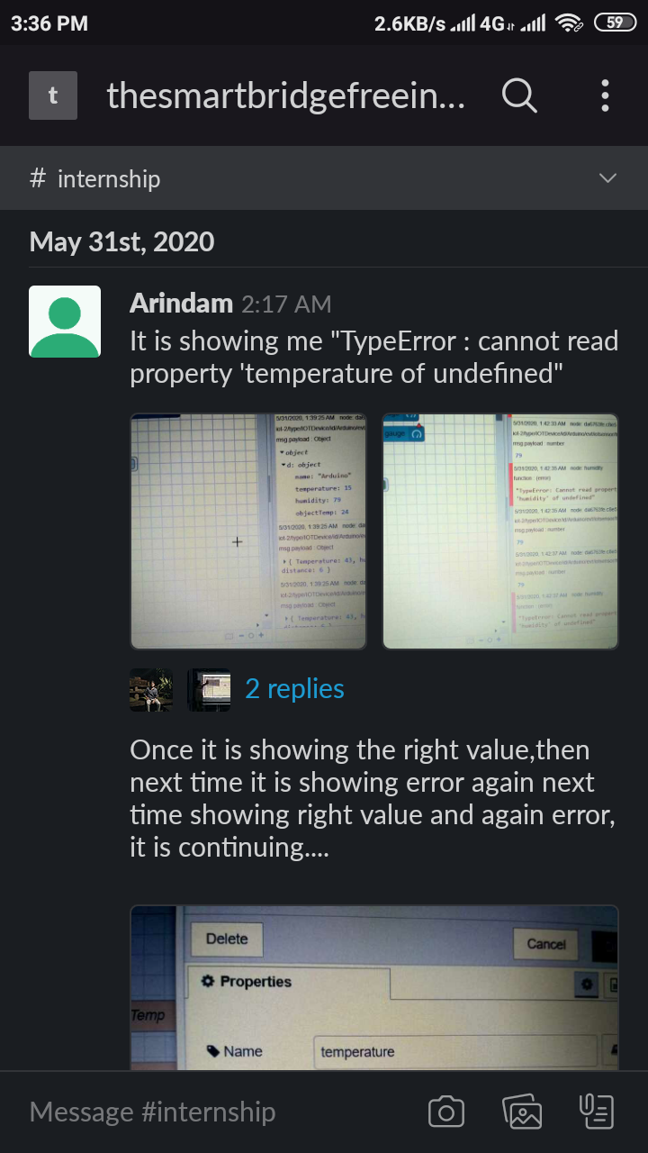

* Explore IBM Cloud Platform:

1. Create IBM Cloud Account: I have created my IBM cloud account.I am doing this project by using this. I have created it with my institutional mail id.

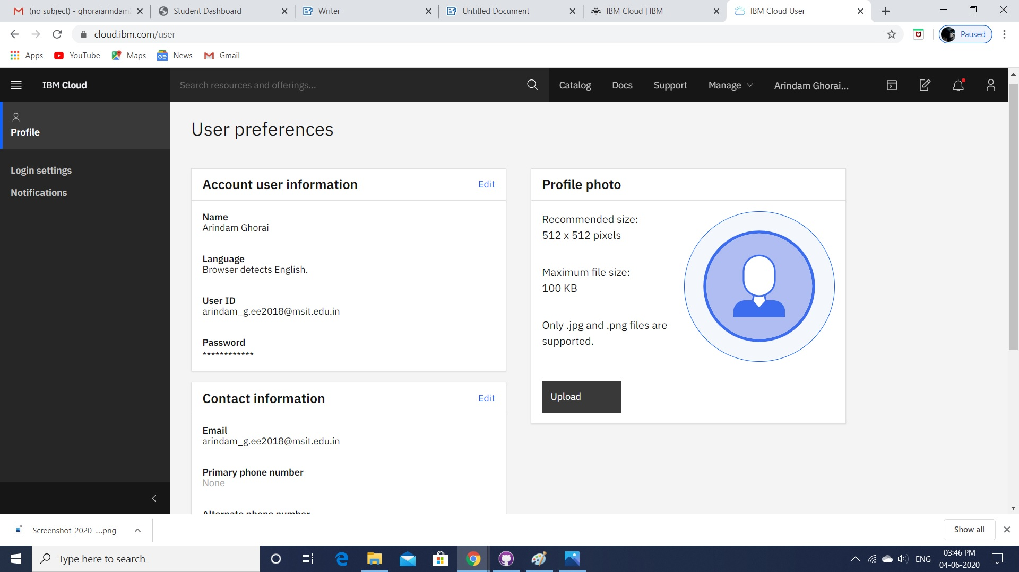

2. Install the Node-Red locally: I have installed it and ran it.

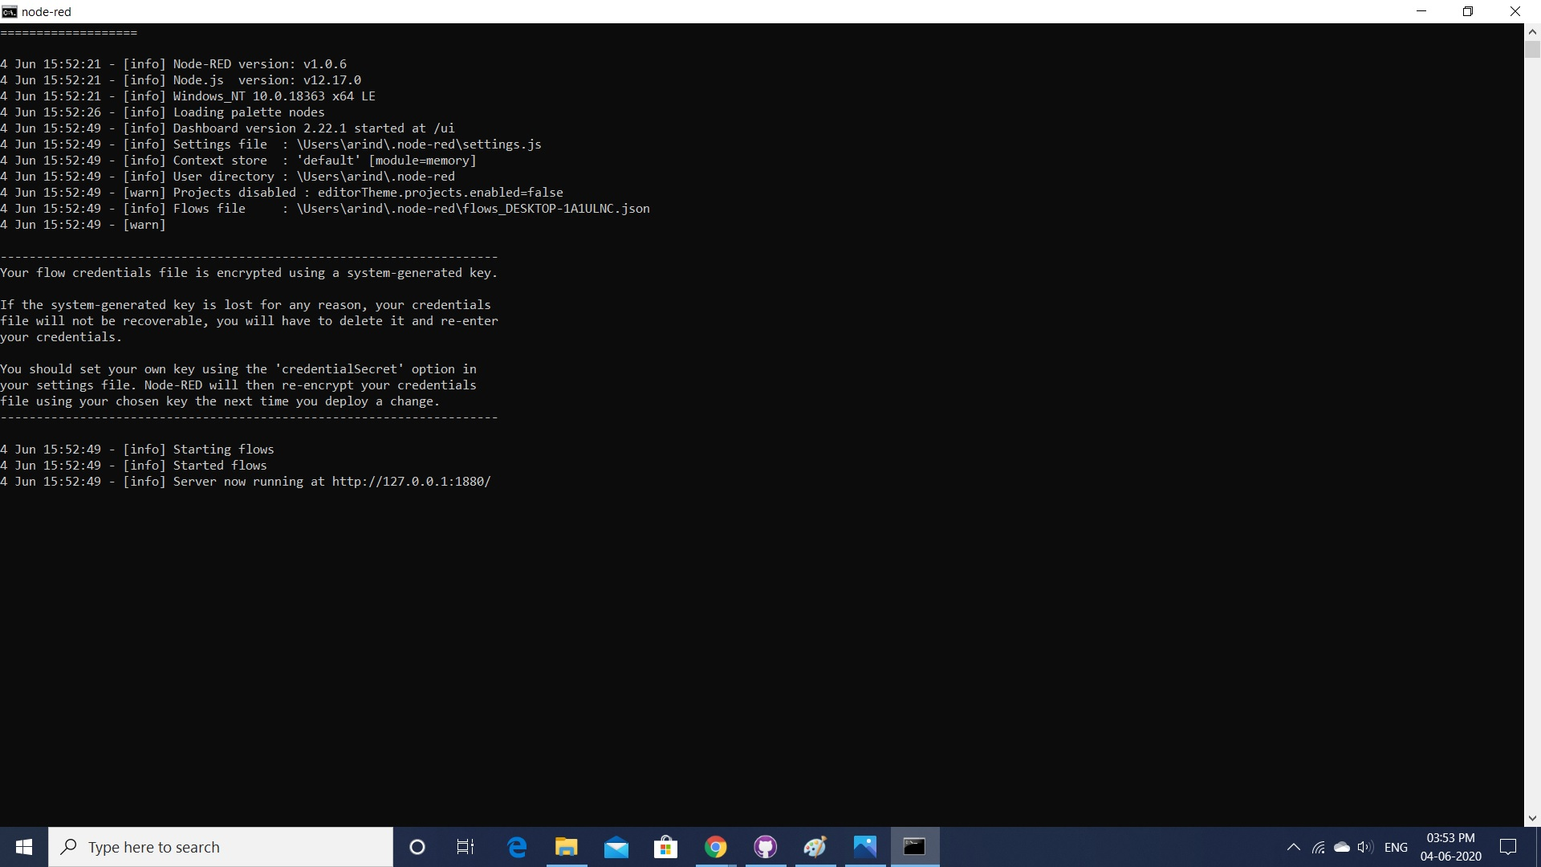

3. IBM Watson IOT Platform: I have created my account and working with it.

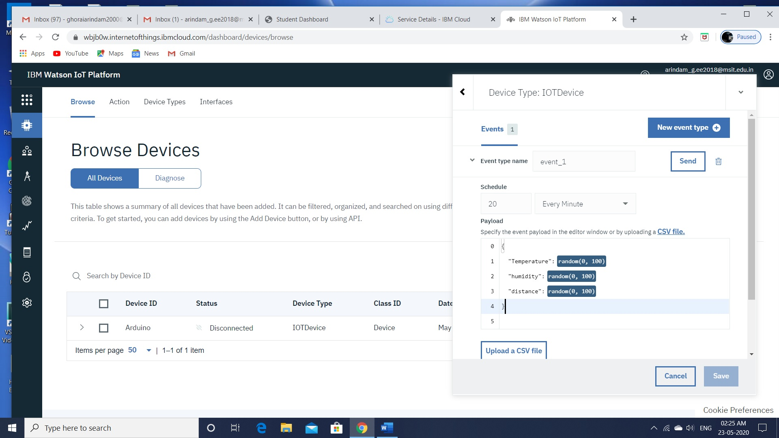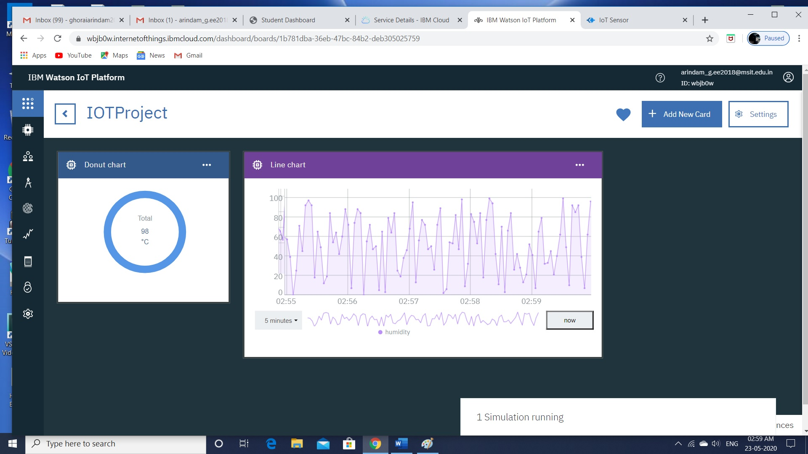

4. Install Python:I have a python software. So, till nosw I have not installed Python Idle as mentioned in eork space which has been given by smartinternz.

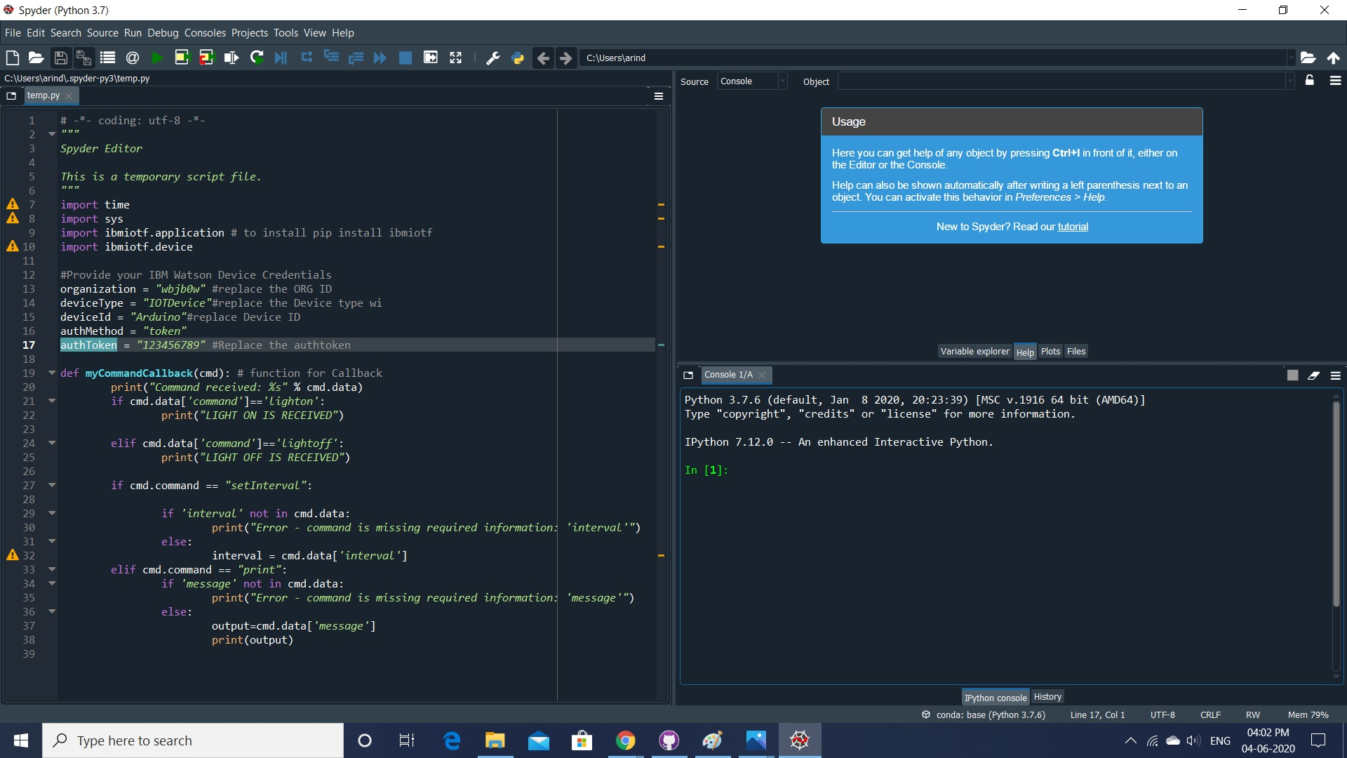

### **Connect The IOT Simulator To Watson IOT Platform**: Then, I have connected it with watson IOT Platform.

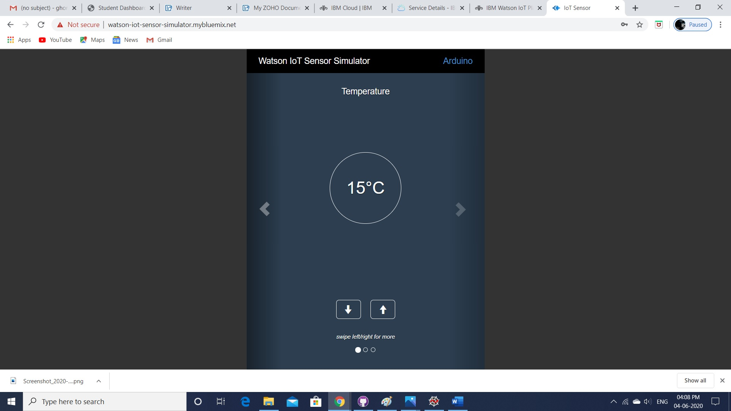

### **Configure The Nodered To Get The Data From IBM IOT Platform And Open Weather API****:**

I have created my account on open weather api platform.

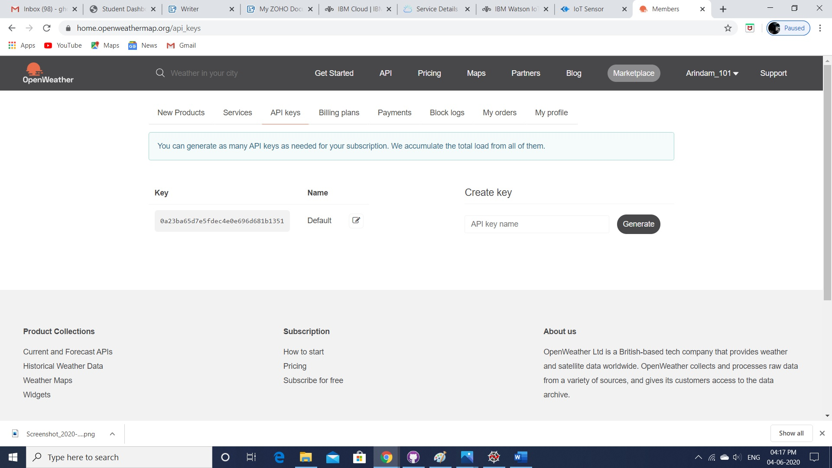

I have made my api key. Then, in city name place, I have entered my city name and then, I have generated on link and in the api key I have just put my city link and then api key and then I am able to get the data.

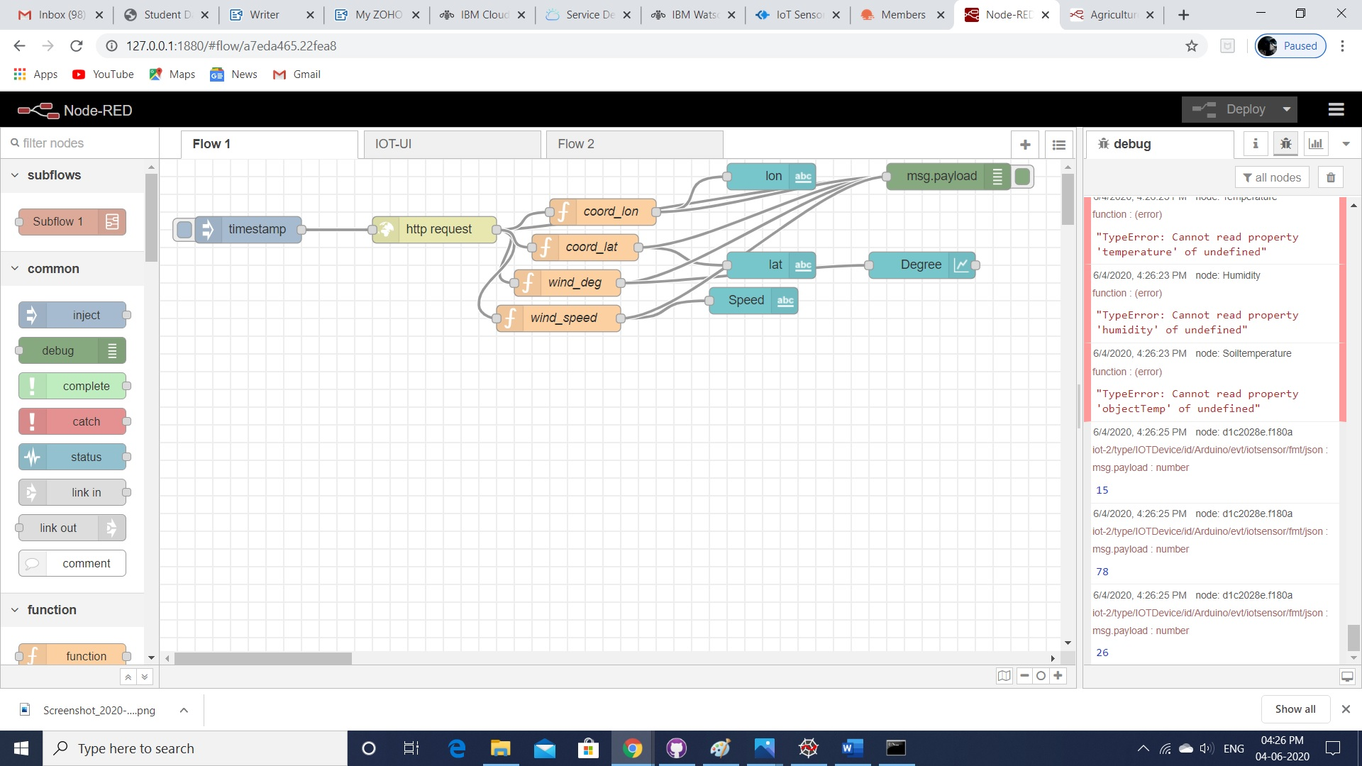

I am getting the weather data from http request. In the UI, You will see that value.

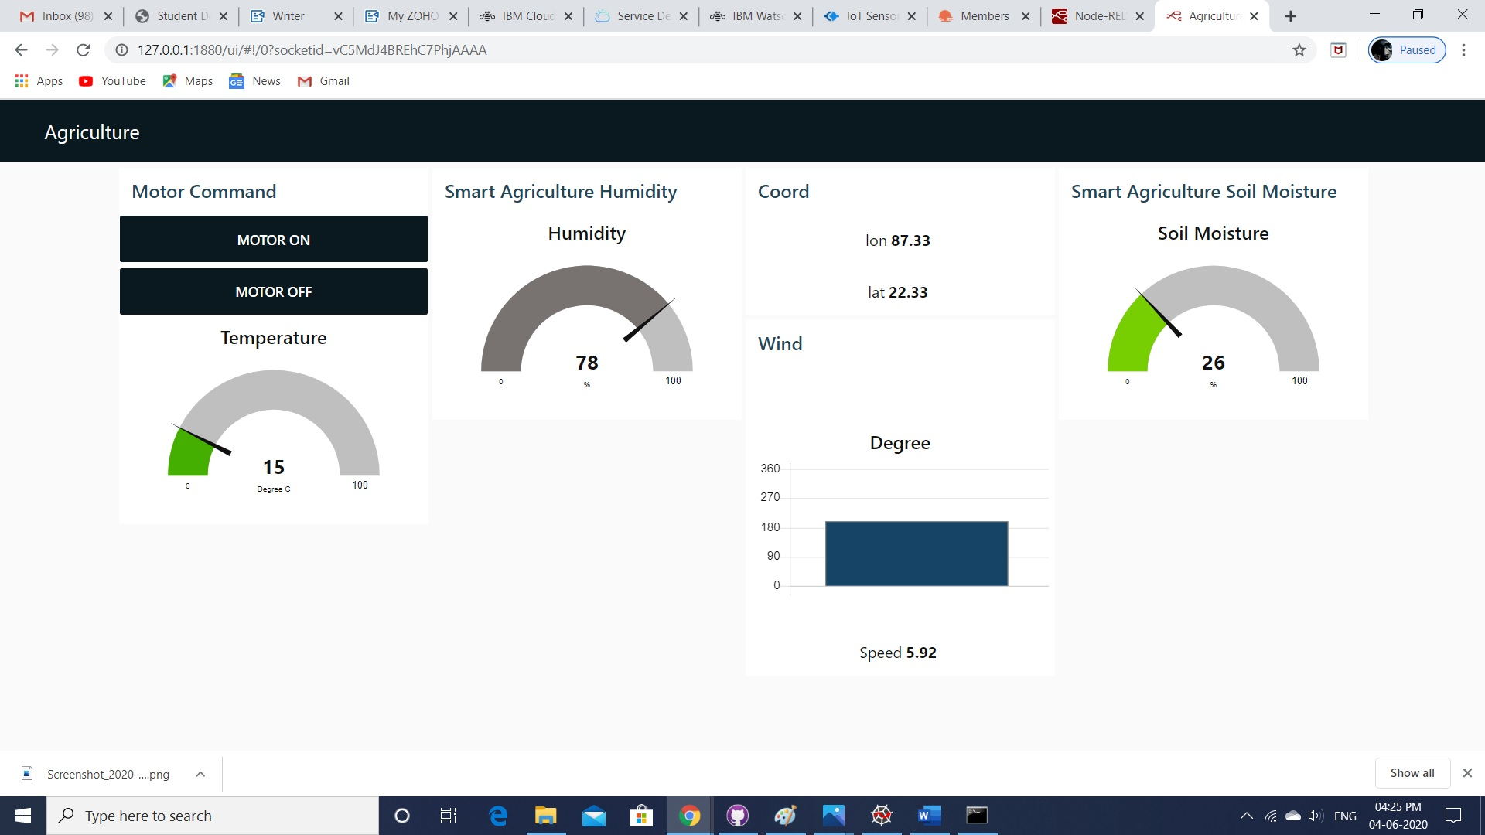

* **Building A Web App**: Web App building process is running. Trying to make a better UI.For, that reason only, process is still going on.



:

**Final Outlook of MY APP**

FINAL OUTLOOK OF AGRICULTURE SECTOR:

(DATA FROM IOT SENSOR):

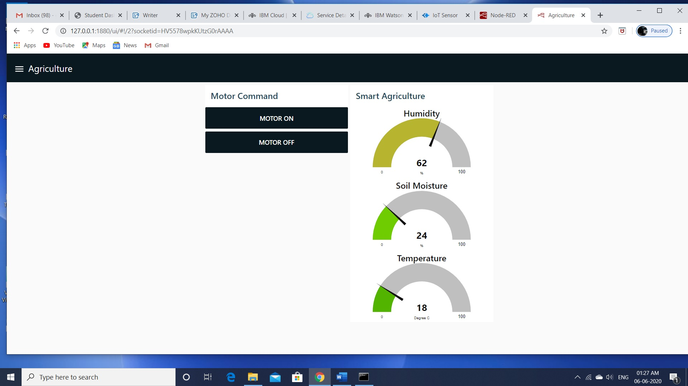

Final LOOK of weather page but It will modify:

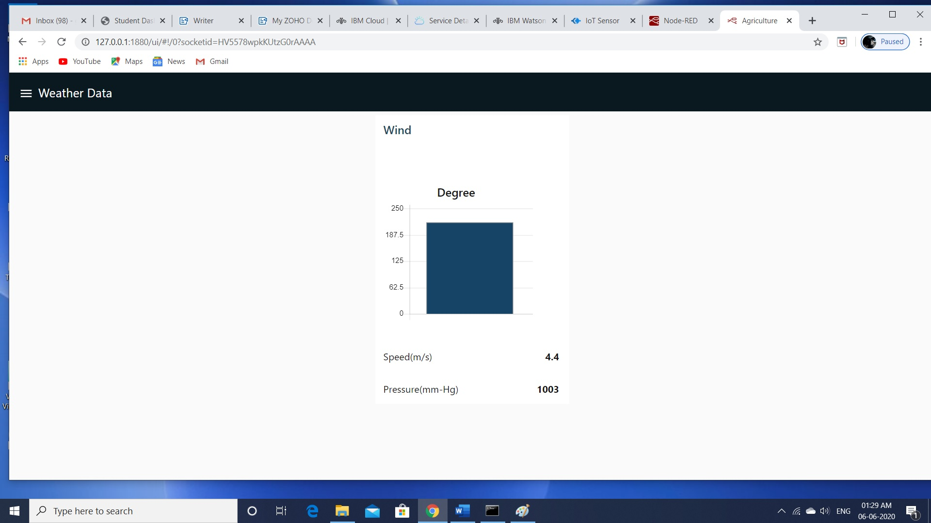Final LOOK of home page(It will modify later):

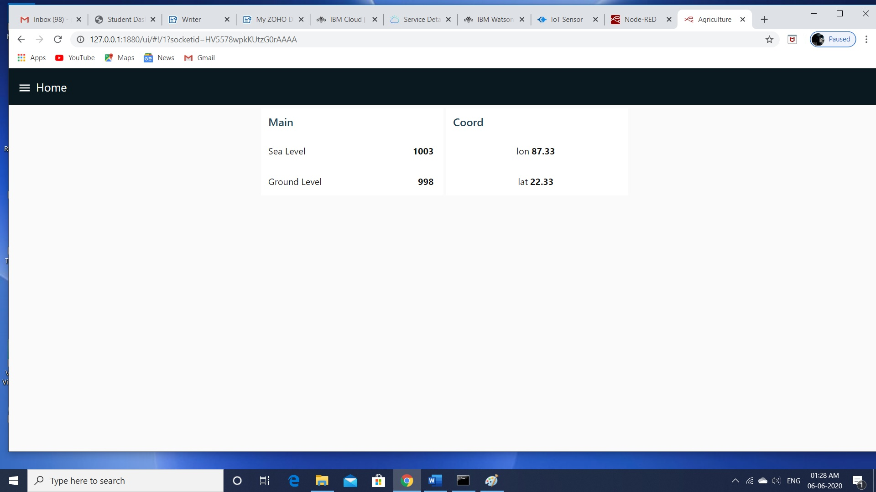

### Configure Your Device To Receive The Data From The Web Application And Control Your Motors:

From UI, You can control motor on/off. I have successfully completed it. If you press motor on, on python platform you will see as a output it receives the signal "motor on" and in the same process you will see "motor off". I have attached my document.

